Together with the Churches of the World

2021 Sunday Prayer Worship for
Peaceful Reunification of the Korean Peninsula

“Seek Peace and Pursue It.”
(Psalm 34:14)

Sunday, August 15th, 2021

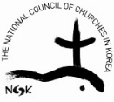
National Council of Churches in Korea
Reconciliation and Reunification Committee
Theme/ Lectionary
“Seek peace, and pursue it.” (Psalm 34:14)
Goals
- To pray, with all the churches of the world, for the reconciliation and healing of the divided Korean Peninsula
- To overcome the South/North antagonism and conflict by actualizing the spirit of the Panmunjom Declaration and the Pyongyang Declaration
- To foster an environment which will establish a permanent peace system on the Korean Peninsula by ending war and concluding a Korea peace agreement
- To create a spirit of cooperation and solidarity among the churches of the world who pray for peace and reunification of the Korean Peninsula as well as for peace in the global village
Background
- August 15 is celebrated as Liberation Day in Korea, the day that signifies Korea’s liberation from Japanese colonization.
- In 2013, the WCC 10th General Assembly meeting in Busan, Korea passed a resolution that the churches of the world will annually observe each Sunday prior to August 15 as a “Sunday of Prayer for the Peaceful Reunification of the Korean Peninsula.”
- The Reconciliation and Reunification Committee of the NCCK drafted this liturgy in the hopes that each church could apply it with reference to their own situation.
- The Joint Prayer for the Peaceful Reunification of the Korean Peninsula is usually prepared by both the NCCK (South) and the Korean Christian Federation (North) together.
- In 2018 the two leaders from North and South Korea met and adopted the Panmunjom Declaration and the Pyongyang Declaration. In order to fully actualize the spirit of these two declarations, NCCK declared a People’s Korea Peace Agreement and is currently engaged in a global campaign to secure 1 million Christian signatures. Please join this signature campaign with your neighbors, relatives and neighboring communities. Peace is approaching us.
2021 Sunday Prayer Worship for
Peaceful Reunification of the Korean Peninsula

{Order of Worship}

Sounding of the Gong (Praying for the presence of the Trinity God - 3 strikes)

Call to Worship (Please stand)

Liturgist: God of creation, you brought life to all that we see. You set the boundaries of the universe and placed us within its care.
Congregation: Creator God, breathe life into your creation.

L: Holy Spirit, you bind your children together in community. Your bonds transcend borders created by humankind. You kindle the fire within us that stirs our passion for faith, justice, and reconciliation.
C: Spirit God, inspire us to reconciliation.

L: Jesus the Christ, you came to teach and to lead. You showed us the cost of discipleship when you stood up against the powers of the world, and they tried to suppress your truth by sentencing you to death. Your life was more powerful than death and your truth lives on in us.
C: Jesus the Christ, help us reflect your light of truth and peace.

Opening Hymn: “Ososo Ososo”

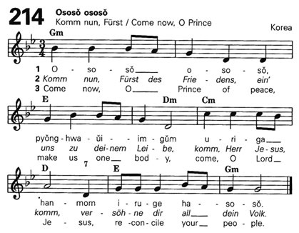
L: God, please be with your people in Korea as they open a new era of peace, prosperity and reunification. Empower the Church in North and South to uphold the spirit of the Panmunjom Declaration and work until this spirit permeates all levels of their life. Show them the path to the land where they will study war no more, where the Korean Peninsula becomes one in peace again.
C: God of the Holy Trinity, please be with us. (Please be seated)

Confession of Sin

L: God of forgiveness, we often stray from your path. As soon as we begin the journey we become easily distracted. We flirt with ideologies that distort your reality. We reduce our neighbor to an enemy image when we should honor each other as beloved children of God. We neglect our neighbor’s needs and place our own interests as an idol above your commandment to reconciliation. We ignore our neighbors’ wounds and claim that, “God only cares about my suffering.” We take steps in the direction you lead us sometimes, but we become tired and lose energy. We lose faith in your ability to carry us on your path when your living water should fill us with all that we need. God, please turn us back to your path and fill us with the strength to persist. In your mercy, unite us as one.
Sung Confession: “Jesus, Remember Me”

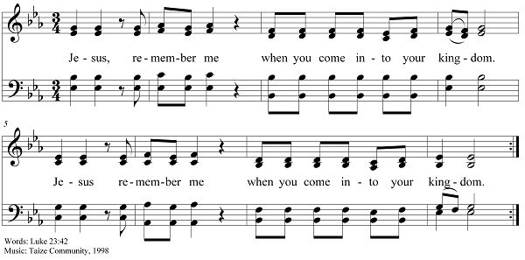

Assurance of Pardon

L: Friends, believe the good news. In Jesus Christ you are forgiven. Now extend this same grace to your neighbors around you.

Sung Response: “Laudate Omnes Gentes”
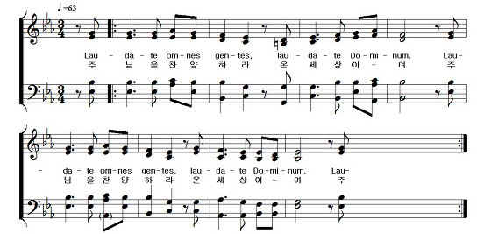
{Hearing the Word}

Prayer of the Day

Scripture Reading: Psalm 34:14

“Seek peace, and pursue it.” (NRSV)

Sermon

{Thanksgiving and Response}

2021 North South/South North Joint Prayer for Peaceful Reunification

God,
We love this land.
This place where the people of North and South Korea/South and North Korea have built our own history,
A land where the records of our life, the weeping and the laughing, are engraved upon it,
We love this land.
But God,
This land, the Korean Peninsula, is groaning,
Because the wounds of our division have yet to heal.
Our two divided peoples have spent decades hating each other.
Our ideologies differ, a physical boundary has been drawn,
And they drive this land into war and violence.
We’ve created a gap within us that is difficult to narrow.
Those that parasitically feed on the conflicts and divisions of the land,
Are blocking the steps toward peace.
Tensions between neighboring countries surrounding the Korean Peninsula never end,
And this clearly lays a heavy burden on the people's lives.
But God,
Please hear our lament.
We sincerely hope the wounds of division will heal.
Have us stop hating and criticizing each other,
And in that space plant the seeds of peace and coexistence.
In that inner gap between the boundaries of ideology,
Let the love of Christ be resolved.
May the desire of all who block peace crumble away.
May all military exercises using the name of security cease,
And may this land, the Korean Peninsula,
No longer be caught up in war and violence.
Also, God,
Let the churches of North and South Korea/South and North Korea take the lead in the call for reconciliation and peace.
Rather than the faith of Christians seeking their own benefit,
To heal the wounds of division instead,
Let us pursue the faith of prayer and devotion.
To unite North and South Korea/South and North Korea,
Let Christians know the appropriate actions,
And let us be determined and take action by the power of the Lord.
God of Peace,
Today marks the 76th anniversary of Korea's liberation from Japanese colonial rule.
And to achieve true liberation, we are trying to revive the embers of North-South/South-North reunification.
We confess that peace and coexistence on the Korean Peninsula is not an option,
But rather a Christian calling that we must fulfill.
Although the barbed wire of division,
Separates the Christians of North and South Korea/South and North Korea,
Remembering that our souls and hearts are connected in God,
Let us walk together on the long road to the peace of this land.
In God’s name we pray. Amen.

(This prayer was written by the National Council of Churches in Korea of South Korea in hopes of renewing joint North/South composition of prayers next year.)

Response to Prayer: “I Give My Peace unto You”

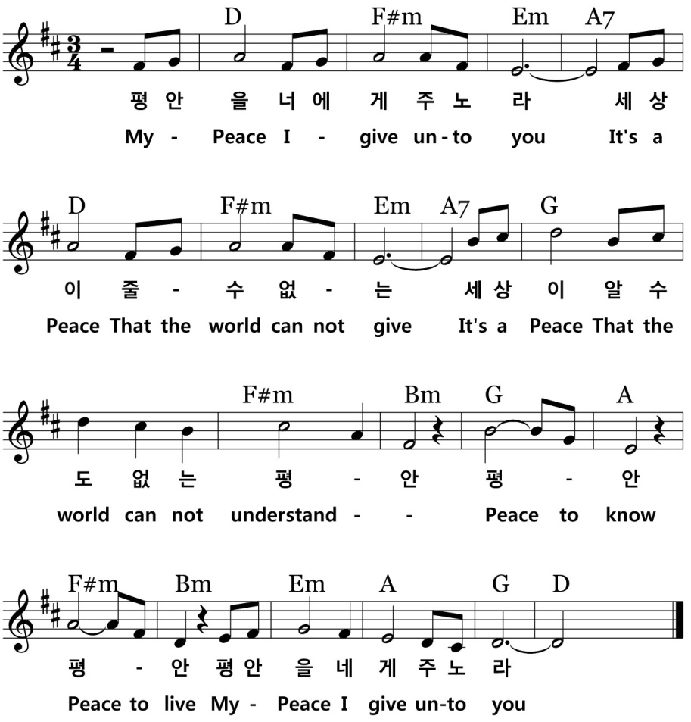

Offering
{Sending to the World}

Sharing of Peace

L: God grants us peace not so that we can hide it away in a dark room to keep ourselves comfortable. God grants us peace so that we may share it with all those around us, neighbors near and far. God calls us to take this peace into uncomfortable situations of conflict. It is a peace that passes all understanding. It is a peace more powerful than all machinations of violence. It is a peace that challenges dangerous idolatries. It is a peace that binds us together even across boundaries of conflict. May that peace fill you up until it overflows. May the peace of the Lord be with you.
C: And also with you.
L: Now, filled with the transcendent peace of God, reach out and share it with those next to you.
(Everyone exchanges the sign of peace according to one’s own custom.)

Closing Hymn: “The Peace of the Earth”

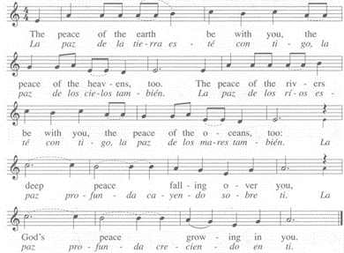
Blessing (can be read by leader or in unison)

All: May the blessing of God be with you all. May the healing of God restore your wounds. May the peace of God transform your communities in conflict so they may become communities of God’s commonwealth; a commonwealth where all God’s children receive the bread and water they need to survive and live life in abundance. May the Korean Peninsula become one again. May God grant you the power to go out into this world and join God in the work of cultivating this peace. Amen.

Concluding note from NCCK to our partners:
Please participate in the Korea Peace Appeal Campaign:
https://forms.gle/ijY3rVrfZtsMwFjT7
If you have used this service liturgy, we thank you. Please send a brief note to Kurt at kurt.pcusa.ncck@gmail.com so that we will have a record. In addition, the NCCK welcomes any suggestions for improvement.

