NCCK STATEMENT ON HAGIA SOPHIA

The members of the NCCK, which represents millions of Christians in Korea, are deeply saddened to learn of the Turkish Government's conversion of Hagia Sophia from a museum to a mosque, and in this statement we strongly protest this unexpected and sad event.

This is in direct violation of the agreement with UNESCO which designated Hagia Sophia as a “World Heritage Site” in 1985. Hagia Sophia was built, as is well known, by Emperor Justinian I, as a Christian church and was from 537 to 1453 the cathedral of the Ecumenical Patriarchate of Constantinople. Mustafa Kemal Ataturk turned it from a mosque into a museum in 1934. And in this capacity, this Christian monument functioned for 86 years as a point of unity of all people regardless of religion. However, its transformation into a mosque again is a step back in history, which offends the monument and its mission. If it was necessary to be any change in the status of this monument, it would have to be given back to the Ecumenical Patriarchate, to which it belonged for 916 years!

We fully share the statement of the Ecumenical Patriarch Bartholomew I, which he made shortly before the recent decision of the Turkish Government, that "Hagia Sophia belongs to humanity" and that "Hagia Sophia as a museum is a place and a symbol of meeting, solidarity and mutual understanding of Christianity and Islam."

Millions of Korean Christians were deeply disappointed by this recent decision. In addition, they are very concerned if it is appropriate to visit Turkey any more, since the main purpose of their visit was to go as pilgrims to see and admire the oldest and most beautiful Christian monument in the world.

Joining our voice with the voices of protest of all people from all over the world, we pray and hope that the Government of Turkey will realize the great mistake of its decision and will want to restore Hagia Sophia to its previous legal status.

July 14, 2020

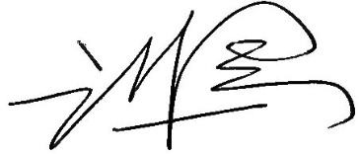
Rev. Lee Hong-jung, General Secretary

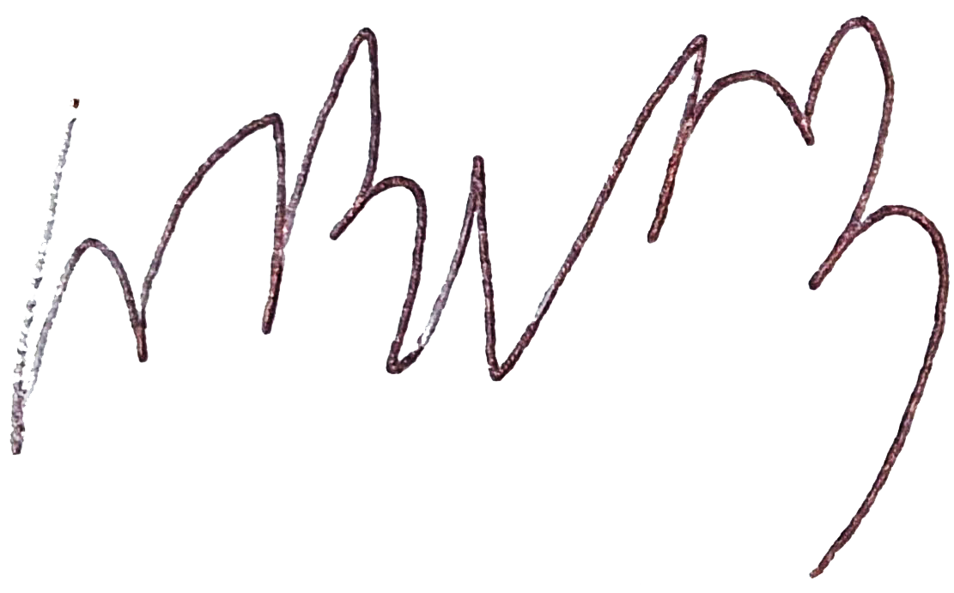
Rev. Suh Ho-Suk, Chairperson of International Committee
National Council of Churches in Korea

